"Дидактические игры на изучение

частей тела".  
  
[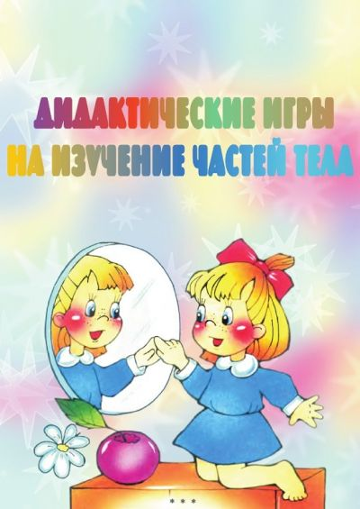](https://sad48.ru/images/remote/http--dg55.mycdn.me-imaget3ampbid594707339953ampid594707339953ampplcWEBamptknTlQXFbxf6LWtWqt_IXEm28g1xek) [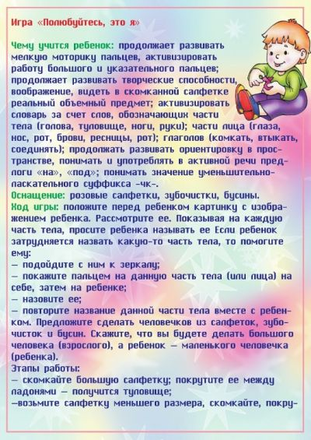](https://sad48.ru/images/remote/http--dg55.mycdn.me-imaget3ampbid594707336881ampid594707336881ampplcWEBamptknshYRukm1WpL437jxRaKnEOQXxZ8)[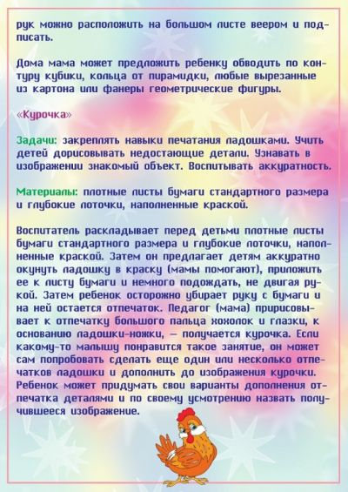](https://sad48.ru/images/remote/http--dg55.mycdn.me-imaget3ampbid594707337137ampid594707337137ampplcWEBamptknZoVkzhAZghickbDlkbOUZs2VxHA) [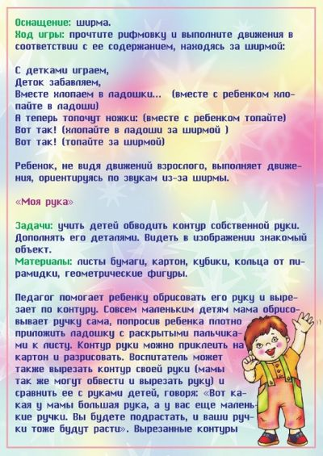](https://sad48.ru/images/remote/http--dg55.mycdn.me-imaget3ampbid594707337393ampid594707337393ampplcWEBamptkndE1fSmrnOuUZcCBiFQBByo18lQc)[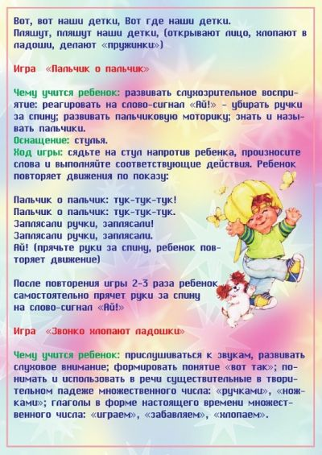](https://sad48.ru/images/remote/http--dg55.mycdn.me-imaget3ampbid594707337649ampid594707337649ampplcWEBamptknWLbKk3agPJW52eszoorAv20MNoE) [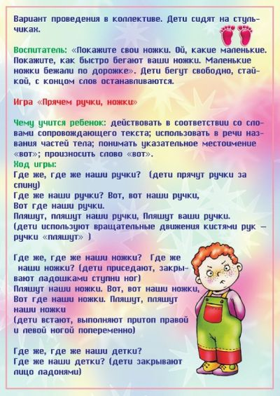](https://sad48.ru/images/remote/http--dg55.mycdn.me-imaget3ampbid594707337905ampid594707337905ampplcWEBamptknM1-1toc2hArdRnlL6Cu9_TptfVs)[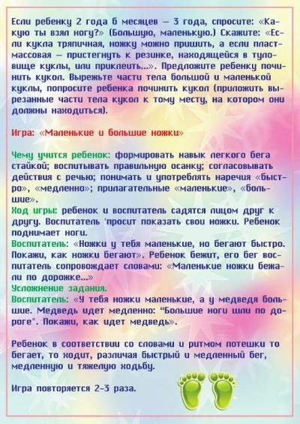](https://sad48.ru/images/remote/http--dg55.mycdn.me-imaget3ampbid594707338161ampid594707338161ampplcWEBamptknWKnTi3ozXZC572X_hk18zY4EoaM) [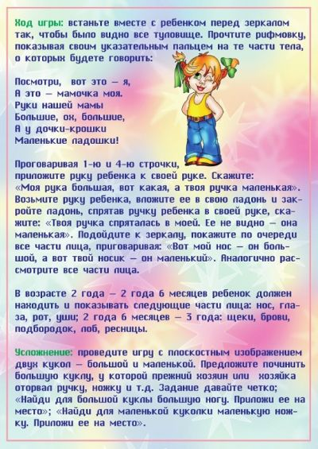](https://sad48.ru/images/remote/http--dg55.mycdn.me-imaget3ampbid594707338417ampid594707338417ampplcWEBamptknbMuFjOTMd3xsuZqBcO0W3dYg_qc)[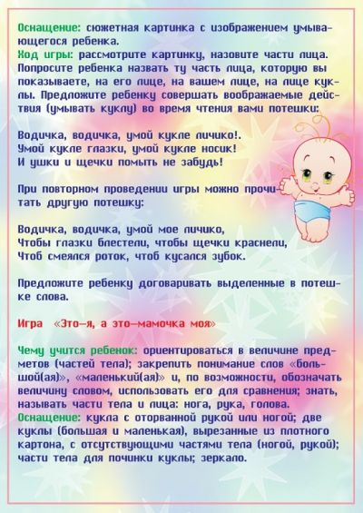](https://sad48.ru/images/remote/http--dg55.mycdn.me-imaget3ampbid594707338673ampid594707338673ampplcWEBamptknA07pNG6yDy2L1EnqXYt2_DhHikk) [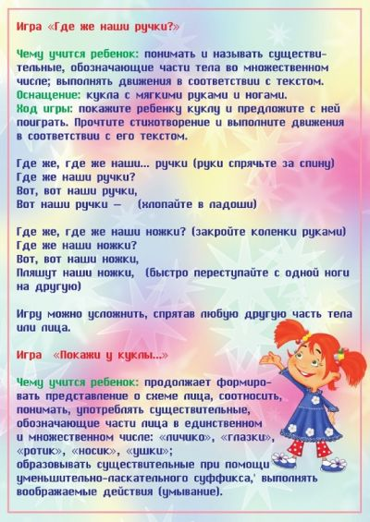](https://sad48.ru/images/remote/http--dg55.mycdn.me-imaget3ampbid594707338929ampid594707338929ampplcWEBamptknzwIlDFh4oSvKNSs1fX_1OGV5CD0)[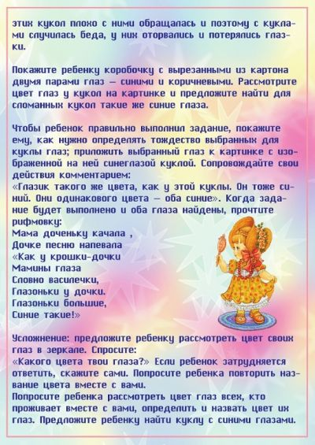](https://sad48.ru/images/remote/http--dg55.mycdn.me-imaget3ampbid594707339185ampid594707339185ampplcWEBamptknNaXPTraFaNpM6ssOZNAa_DiUJII) [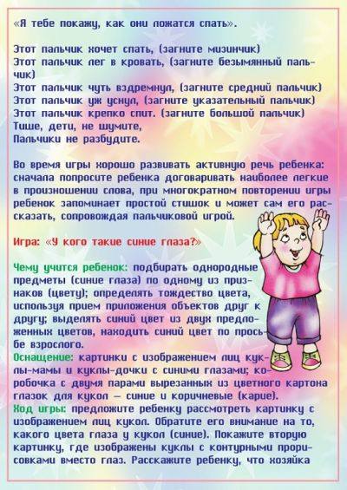](https://sad48.ru/images/remote/http--dg55.mycdn.me-imaget3ampbid594707339441ampid594707339441ampplcWEBamptknjzlUlNZfrJt_uFAWLBfisL7sNqc)[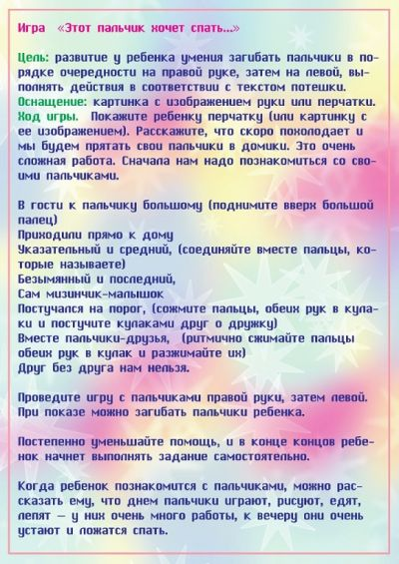](https://sad48.ru/images/remote/http--dg55.mycdn.me-imaget3ampbid594707339697ampid594707339697ampplcWEBamptknd6gdMfi_DgYvJ59mbd_pMVTxczU) [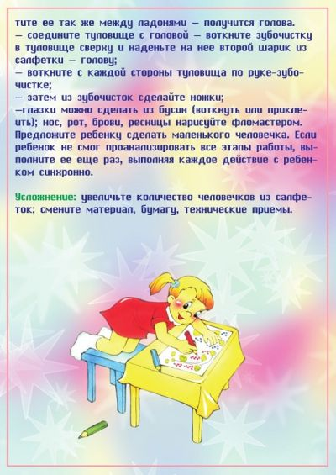](https://sad48.ru/images/remote/http--dg55.mycdn.me-imaget3ampbid594707340209ampid594707340209ampplcWEBamptknC2bvTuEa43y1zDq5ntOqnA-ypuQ)