Representation View’s Adequacy Criterion
Aleksandr Bajdalin
IMM UrB RAS
Yekaterinburg, Russia
bajdalin@gmail.com

Abstract
The paper contains statement of the some problems in the Parallel Software Visualization domain. The problems of 3D graphics and animation uses in Parallel Software Visualization are considered. A criterion of the structural correspondence between model entities, visual objects and mental images is offered.

1. Introduction
One of the most serious problems in parallel programming, debugging and performance tuning is the absence of theoretical approach to represent parallel program and its execution process .
Usually it can be solved by increasing volume and detalizatioin level of raw debugging data. Great amount of low-level info overflows user's mind and programmer can't understand process. As a matter of fact even the most detailed time profiling can help only to find out the most ineffective code block or function call. We can only modify program and analyze performance form many times. There is no silver-bullet method to correct ineffective code [4,5,7].
One could say that performance debug has two problems (or questions) – local and global. Local means that we have profiling data, somehow gathered due to some effectiveness model, and we have to represent it for programmer who wants to increase program's performance. Now many debugging and profiling systems are existed, but practically each of them is designed “ad hoc” or using simple views like ParaView. In general it can be solved only if one has methodics “how to design representation view”. But this methodics can't be simple like cooking advices.
Global problem of performance debugging, may be, more globally – of parallel programming – can be formulated as following. Programmer doesn't know how to imagine execution of parallel program. Now we use approach, which is inherited from traditional programming. But factor of time is very important for parallel program oppositely to sequential programming. Parallel program has amount of work flows, which negotiate with other ones. These negotiations and communications can be called as the soul of parallel programming and make parallel programming to differ from sequential applications. If one wants to deal with parallel process, he needs represent execution dynamics and to help programmer to insight about it [8,9].
2. Visualization and interpretation
Here we have no aim to speak about researching new approaches of parallel processes, but we should “remember” some facts about human perception. Person can understand something about dynamics only being immersed in this process, by human's memory and sense of time. And human can's recognize processes which are very slow (like growing of grass) or very quickly (like air ball exploding). Its reason is human's mind psychophysiology. Mankind invents technical solutions such as rapida (ultra high FPS shooting) to VIEW processes of another evaluation speed. But human, being in time-point, looks at just one point of process and can't look over whole process .
To solve this problem the abstraction is usually used — when process-in-time is represented by process-with-parametrization. The scalar parameter is interpreted as time flow. It is possible to tell that a user takes a detached view of process. It's similar to look after road traffic being staying at roadside. There is a hypothesis that there are ONLY 2 ways of process representation for user - or we «look a film», or «we look at the function graph» [9].
In spite of the fact that the problem of representation method (view) quality comparison has not been solved yet, and it's too much connected with researcher's subjectiveness there is an opportunity to formulate the quality criterion. It's also the principle of representation view design.
Let's consider visualisation process. First of all the visual image is produced based on mental representation (mental model). Then new mental image is reconstructed from this visual image. But this new mental image can differ from the original. Process of formation of a mental image on graphic is the process of interpretation defined by psychophysiological features of a human brain and thinking. Basically, interpretation laws can be considered as constants, at least in certain social and cultural group.
Decomposition is one of the most important aspects for interpretation problem. Here the single visual image (really it's raster image at the eye retina) is decomposed on components composing it. AT the same time the decomposed image has some structure. Later this structure is involved into reconstructed mental image. Here and next in this article structure of something is summary and kinds of relations between components, object being consisted of.
2.1 Adequacy criteria
It is known that, studying object or the phenomenon, the person constructs a mental model. The complete object is represented in the form of more simple components collection. Whole object has been decomposed into parts, and person has got a knowledge about object structure. The same process takes place at interpretation of a object visual image. Therefore, it is possible to say that the visualised object should be represented so that the structure of the recreated object should be THE SAME as the structure of the studied object. It is also criteria of the visualisation adequacy.
However in tasks of scientific and informational visualisation very often it is necessary to deal with objects which are abstractions and have no visible incarnation in the real world [1,2,4,5,10]. Nevertheless, the person works with them in the same way, representing the complete object in the form of a collection of more simple components linked among themselves by ratios. It can be as well familiar «X is part of Y», «V behaves as W», and more specific. In any case – at the expense of splitting of the complete object into components we can represent it to ourselves. Then it is possible to tell that the criterion of adequacy is formulated as follows.
2.2 How to design adequate representation view
The structure of object reconstructed from visual image is based on (inherits) visual image structure. Interpreted object’s structure should not contradict origin mental structure, in terms of relations, produced by structure. Then one can say about method or advice to design adequate representation views. This method is said as:
1) to study visualizing object (process, phenomenon or informational “raw data”) and to find out its composition (components and relations between them);
2) to decide about importance of relations (and components), which ones should be interested and then be shown and which relations should be omitted;
3) to choose representation views for chosen components and relations;
4) if necessary, to apply this method (decompose and choose views for parts and relations) to object’s components until achieve atomic elements like scalars;
5) to compose representation views, chosen for parts and relations, attentively preventing composition being interpreted producing other mental structure;
6) to provide additional information about omitted parts and relations, if they are omitted;
7) to provide additional representation views or visual images for details, if they are reduced.
2.3 Visualization system as an example for this method
The development of representation views for visual performance analysis of DVM-programs can be presented as an illustration [3].
The base unit of performance debug information on productivity is a tuple of scalars. This is the set of common execution time addends describing the task fragment (code block or interval) executed by concrete processor. These units are grouped in arrays.
The intervals selected from the source text, are included to higher level intervals, the whole program is zero-level interval. So intervals have tree structure. Vertices of this tree contain arrays of time characteristics.
On the one hand it is necessary to display interval tree structure, on the other hand one should know about interval performance on set of processors. Attempts to use tridimentionality at representation views for tree structures have led to the DVM-programmer misunderstanding about performance leaks. As consequence, programmers are impossible to analyse program performance. At the same time tridimentionality is well used for more convenient layout of visualised objects and user’s interaction with them [6, 24, 15-18].
3. Cognitive structures are the base of interpretation and adequate representation view design
Such phenomenon as drift of visualization techniques exists. It is shown as transitions of visualization metaphors and corresponding views from one visualization domain to another, for example, from Information and/or Scientific Visualization to Software Visualization. This drift serves as the manifestation of unity of various visualization domains. The analysis of results of metaphors [1,2] and views transitions in different visualization domains has shown the presence of some regularity independent of visualized information nature. This regularity determines a success or a failure of visualization technique transitions. To achieve a success it is necessary the connection between the internal nature and structure of modelling objects (and the data corresponding to them) and internal mental structures of users. In this structure (so called representative cognitive structures) his/her image of phenomena is mapped [11]. Correspondents between model and cognitive structures are not arbitrary. As simple example representations of tree-like structures may serve. Similar views are used in spite of various nature of these structures and the most various applications in Information and Software Visualization domains.
The person distinguishes any general logic in a picture, breaking it on set (perhaps enclosed) fragments, abstracting from minor elements [11].
Thus, it is possible to speak about cognitive structures, structures of entities under analysis and structures of visual objects and images.
When analysing a visual image interpretation proceeds in two phases. The elements interpreted according to the knowledge extracted from a dedicated domain are revealed.
The information on interrelations between these elements is extracted (reconstructed) from the general visual image. Thus, a coherent adequate representation about visualized object is provided. That is the interpretation proceeds in part on the base of the visual image itself, and in part on the base of the analysis of its elements and their interpositions.
The information on element interrelations specifies the structure of a visualized object or more exact, our presentation about it.
Process of visualization may be considered as construction of visual (geometrical) image on the basis of abstract representation about object. These abstract representation are model (object, the phenomenon, process under investigation), somehow connected with user cognitive structures describing a given entity. Visual images representing modeled entity, serve to create or extract by it cognitive structures.
The purpose of researches in visualization domain is to create such techniques and principles which will provide the extraction adequate cognitive structures on visual images. A process of interpretation is exactly the generation of cognitive structures on base of visual images. This process is inverse or more exactly dual to visualizations. As visualization principles the interpretation principles should exist.
Views of structure assume independent from specifics ways to represent the elements which are taking place in given relations. The view of structure is a way of specification of its interpretation techniques. Objects of interpretations determine a concrete specification of views based on specificity of initial entities.
Thus, development of a concrete view for a complex initial entity may consist of a choice of a way of corresponding structure representation and ways of its element representations. The arrangement of visual images of structure elements is necessary to provide according to the rules ordering visualization methods for relations between these elements.
However, it is possible to choose wrong ways of visual representation of initial entities. Then interpretation is impossible as images are not clear. Also it is possible to choose wrong ways to represent relations between elements. Then erroneous cognitive structures may be reconstructed only similar to desired one. Therefore a criterion of views correctness is necessary. In this case construction of views may be based on such rule, that structure of the constructed visual image should not contradict to the structure of the initial entity. During the interpretation of visual objects there should not be relations absent in the initial entity.
While a reduction of dimension, as well as a reduction of all structures is not a mistake provided that the user (interpreter) is informed about it. Clearly, when the element is not mapped, relations, in which it was with other elements, are not mapped also. It is undesirable, but in some cases inevitably.
4. Conclusion
A small amount of the systems using 3D graphics and animation Parallel Software Visualization is seemed assignable. Experience of three-dimensional metaphor realizations for parallel program performance tuning systems specifies also some problems as with its effective realization as with data perception, recognition and interpretation. The process of Gantt charts drawing uses for comparative analysis of parallel process executions. The entity nature connected to process of parallel programs development often limits the use of these powerful visualization means. The consideration of problems of structural correspondence between modelling entities, visual objects and mental images shows, that use of tridimentionality and animation for presentations of obviously one-dimensional or bidimentional entities often is superfluous.
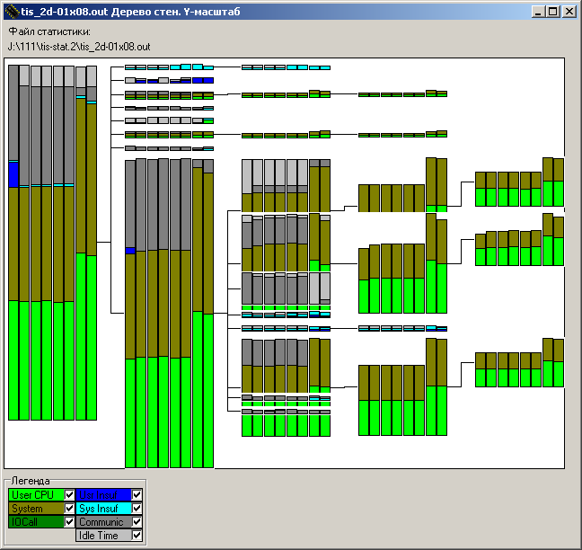Fig. 1: DVM-program complex representation, based on interval tree
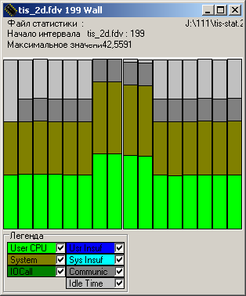Fig. 2: "Interval Wall" represents time characteristics of program block, evaluated on certain CPU array

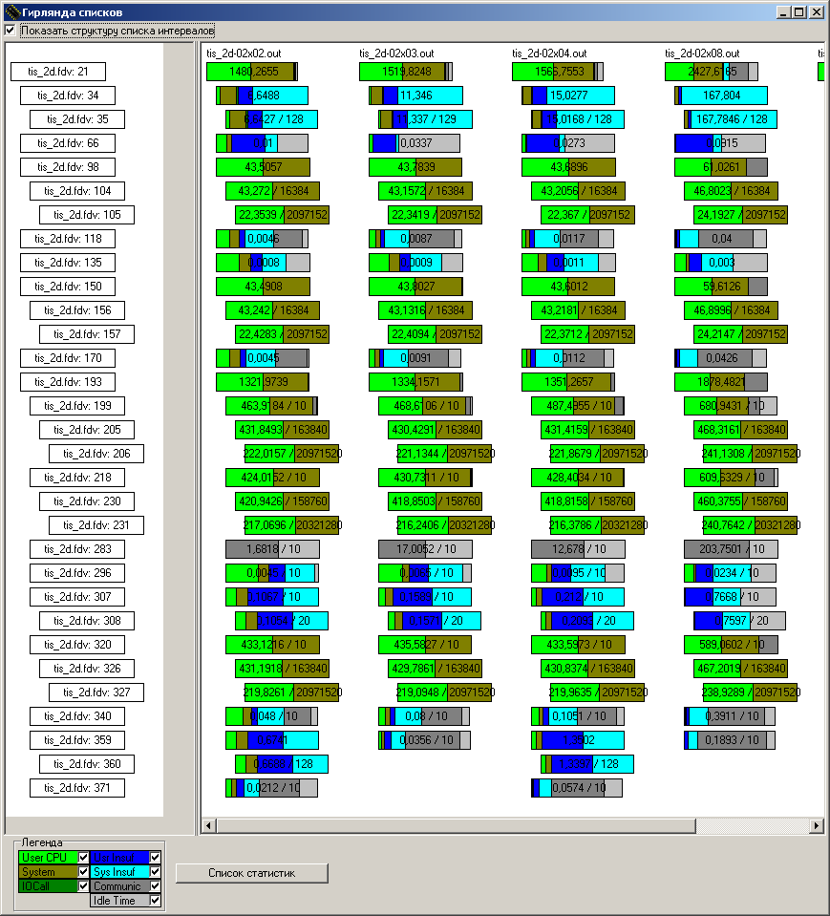Fig. 3: Complex view for detail analyze DVM-program performance. Program was started on some different configurations
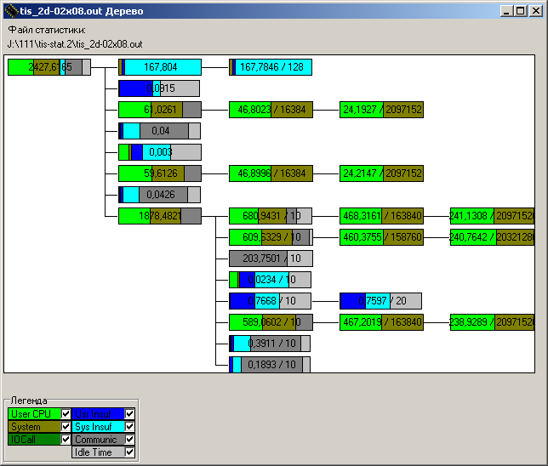Fig. 4: Interval Tree shows common evaluation time characteristics and tree structure
Fig. 5: Relationship between views. Interval Wal has been called from Interval Tree and shows concrete performance data

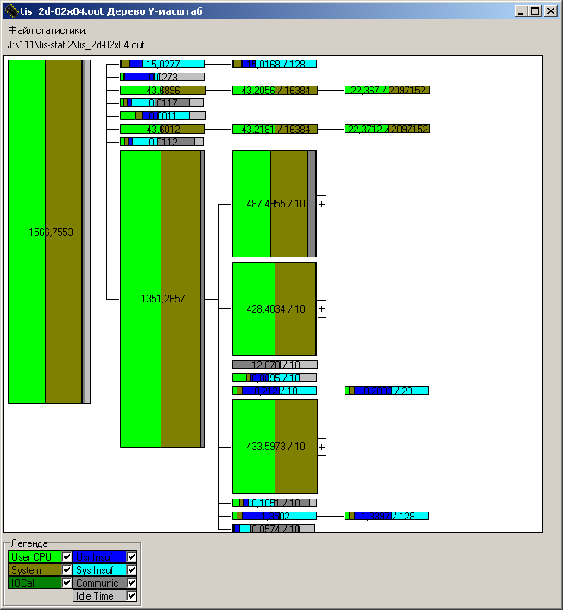
Fig. 6: Vertical-Scaled Interval Tree represents structure and ratio (eval.time) between intervals
Fig. 7: Set of detaled representations, available from each interval tree node

References
- Averbukh V.L. Toward Theory of Computer Visualization // Computational Technologies V.10, N 4, 2005, pp. 21-51. (In Russian.)
- Averbukh V., Bakhterev M., Baydalin A. et all Interface and Visualization Metaphors // J. Jacko (Ed.): Human-Computer Interaction, Part II, HCII 2007, Lecture Notes on Computer Sciences, 4551, Springer-Verlag Berlin Heidelberg 2007, pp. 13-22.
- Averbukh V.L., Baydalin A. Yu. Design of visualization for parallel programming system DVM. Algorithm and Programs of Parallel Computing. Institute on Mathematics and Mechanics. Ekaterinburg, 2001, Pp. 3-40. (In Russian.)
- Averbukh V.L., Baydalin A.Yu. Development of Parallel software Visualization Tools. Visual programming and visual debugging for parallel software // Problems of atomic science and technology. Series Mathematical modelling of phisical processes. 2003. Vol 4. pp 68-80
- Averbukh V.L., Baydalin A.Yu. Development of Parallel software Visualization Tools. Program performance tuning // Problems of atomic science and technology. Series Mathematical modelling of phisical processes. 2004. Vol 1. pp 70-80
- Averbukh V.L., Baydalin A. Yu., Ismagilov D.R. et all Three-demensioanal Represetnations of Call Graph // VII International Seminar Supercomputing and Mathematical Modeling. Sarov. Russia. 2003, pp.12-13. (In Russian.)
- Averbukh V.L., Baydalin A.Yu., Ismagilov D.R. et all Situation of Parallel Software Visualization // Proceedings of International Conference on Computer Graphics and its applications GraphiCon'2005 June 10-14, 2005, Russia, Novosibirsk, Institute of Computational mathematics and mathematical geophisics. 2005. pp. 179-186.
- Baydalin A.Yu Analysis of Parallel Software Visualization Entities // Problems of theoretical and applied mathematics. Proceedings of 36-th Regional Conference for young researchers, 2005, Institute of Mathematics and Mechanics Ural Branch of Russian Academy of Science, 2005. pp. 320-321. (In Russian.)
- Baydalin A. Yu. Toward approaches for research of parallel programs // Problems of theoretical and applied mathematics Proceedings of 38-th Regional Conference for young researchers, 2007, Institute of Mathematics and Mechanics Ural Branch of Russian Academy of Science, 2007. pp. 409-411. (In Russian.)
- Baydalin A.Yu., Ismagilov D.R. Structure representation tools in parallel software visualization // International Conference on Computer Graphics and its applications GraphiCon'2006. Russia, Novosibirsk, Institute of Computational mathematics and mathematical geophisics 2006. Стр. 271-274.
- Chuprikova N.I. Mental Development and Learning (toward Motivation of System-Structural Approach). Moscaw-Voronej. RAO Publishing House. 2003. (in Russian)
- Crossno P., Angel E. Visual debugging of visualization software: a case study for particle systems // Proceedings of the conference on Visualization '99:celebrating ten years table of contents San Francisco, California, United States. 1999. P. 417-420.
- Hough A.A., Cuny J.E. Initial Experience with a Pattern-Oriented Parallel Debugger / Proceeding of the ACM SIGPLAN and SIGOPS Workshop on Parallel and Distributed Debugging. May 5-6 1988. University of Wisconsin. Madison, Wisconsin // SIGPLAN Notices, Vol. 24. No 1. (Janiary 1989) pp. 195-205.
- Reed D., Scullin W., Tavera L., Shields K., Elford Ch. Virtual Reality and Parallel Systems Performance Analysis // IEEE Computer, V.28, N 11, (November 1995) pp. 57-67.
- Yu Y., D'Hollander E. H. Loop Parallelization using the 3D Iteration Space Visualizer // Journal of Visual Languages and Computing, Volume 12, Number 2, April 2001, pp. 163-181.
- Staples M. L., Bieman J. M. 3-D Visualization of Software Structure // Advances in Computers (Vol. 49 Academic Press, London, 1999, pp. 96-143.
- Maletic J. I., Leigh J., Marcus A. Visualizing Software in an Immersive Virtual Reality Environment // Proceedings of ICSE'01 Workshop on Software Visualization, Toronto, Ontario, Canada, May 12-13 2001, pp. 49-54.
- Maletic J. I., Marcus A., Feng L. Source viewer 3D (sv3D): a framework for software visualization // Proceedings of the 25th International Conference on Software Engineering Portland, Oregon. 2003. Pp 812-813.

Proceedings of the 10th International Workshop on Computer Science and Information Technologies CSIT’2008, Antalya, Turkey, 2008

